Attention-Enhanced EfficientNetB0 for Reliable Glaucoma Detection from Retinal Fundus Images

Mahfuz Ahmed and Shouna Jahan Deme
A Thesis in the Partial Fulfillment of the Requirements
for the Award of Bachelor of Computer Science and Engineering (BCSE)

Department of Computer Science and Engineering
IUBAT School of Computer Science and Engineering
IUBAT–International University of Business Agriculture and Technology
Fall 2025

Attention-Enhanced EfficientNetB0 for Reliable Glaucoma Detection from Retinal Fundus Images
Mahfuz Ahmed and Shouna Jahan Deme

A Thesis in the Partial Fulfillment of the Requirements for the Award of Bachelor of Computer Science and Engineering (BCSE)
The thesis has been examined and approved,

_____________________________
Dr. Utpal Kanti Das
Professor & Chair, Dept of CSE
Dean, ISCSE

_____________________________
Md. Rashedul Islam
Co-supervisor, Coordinator and Assistant Professor

_____________________________
Dr. Md. Abdul Awal
Supervisor, Associate Professor

Department of Computer Science and Engineering
IUBAT School of Computer Science and Engineering
IUBAT–International University of Business Agriculture and Technology
Fall 2025

Letter of Transmittal
20 February 2026
The Chair
Thesis Defense Committee
Department of Computer Science and Engineering
IUBAT–International University of Business Agriculture and Technology
4 Embankment Drive Road, Sector 10, Uttara Model Town
Dhaka 1230, Bangladesh.

Subject: Letter of Transmittal.

Dear Sir,
Due respect and honor we, Mahfuz Ahmed bearing ID:22203029 and Shouna Jahan Deme bearing ID:22203001, are happy to present my much anticipated thesis report with the title of "Attention-Enhanced EfficientNetB0 for Reliable Glaucoma Detection from Retinal Fundus Images", which you have assigned to me to advance my knowledge and understanding in the field as a CSE student. We are deeply thankful to your guidance and supervision and are honored to have an advisor such as you. It has taken us through this work and we have gained precious practical knowledge that would assist us in developing a goal oriented career. We have attempted to write a very detailed report, though we are new to this field and so maybe some of our limitations are still to be experienced.
I would be very grateful to ask you to please accept my thesis report and focus on my intense work in spite of any error, and make my diligent work fruitful.
_____________ _____________
Mahfuz Ahmed Shouna Jahan deme
Student ID: 22203029 Student ID: 22203001

Student’s Declaration
I hereby declare that this thesis entitled “Attention-Enhanced EfficientNetB0 for Reliable Glaucoma Detection from Retinal Fundus Images” is the outcome of the investigation and research carried out by us, Mahfuz Ahmed bearing ID:22203029 Shouna Jahan Deme bearing ID:22203001, under the supervision of Dr. Md. Abdul Awal, Associate Professor, Department of Computer Science and Engineering, International University of Business Agriculture and Technology. I confirm that all sources and materials used in this study have been properly cited and acknowledged. I declare that this report is original and has not plagiarism or falsification of data.
I take full responsibility for the authenticity and integrity of the research and the findings presented in this thesis.

_____________ _____________
Mahfuz Ahmed Shouna Jahan deme
Student ID: 22203029 Student ID: 22203001

Supervisor’s Certification
This is to confirm that the research project known as “Attention-Enhanced EfficientNetB0 for Reliable Glaucoma Detection from Retinal Fundus Images” has been conducted and reported by Mahfuz Ahmed bearing ID:22203029 and Shouna Jahan Deme bearing ID:22203001 to the Department of Computer Science and Engineering of the International University of Business Agriculture and Technology in partial satisfaction of the degree course of Computer science and engineering, Bachelor of Science.
I supervised the research that was carried out between Spring 2025 and Fall 2025. I would declare that this work is to the best of my knowledge an original work and that it complies with the academic standards that are required in the said degree.
I wish them all the best in their further academic and career endeavors.

_______________________________
Dr. Md. Abdul Awal
Associate Professor
Department of Computer Science and Engineering
IUBAT–International University of Business Agriculture and Technology

Abstract
Glaucoma is one of the leading causes of permanent blindness worldwide, and early detection is essential for preserving vision. This paper presents a deep learning based approach for automated glaucoma detection from retinal fundus images using a lightweight EfficientNetB0 convolutional neural network backbone enhanced with a Customized Convolutional Block Attention Module (CBAM). The spatial attention component of CBAM is modified by incorporating a standard deviation pooling operation, enabling the model to capture second order feature variations and highlight subtle glaucomatous patterns. The proposed framework is trained and evaluated on two publicly available datasets, ACRIMA and LAG, using a comprehensive preprocessing pipeline that includes CLAHE based contrast enhancement and data augmentation. Experimental results demonstrate strong performance, achieving 98.58% accuracy on ACRIMA and 96.09% accuracy on LAG for binary glaucoma classification. The findings indicate that the EfficientNetB0 with Customized CBAM has the potential to emphasize clinically relevant regions, such as the optic disc and retinal nerve fiber layer, which may contribute to more reliable predictions. Due to its lightweight architecture and improved attention mechanism, the proposed model shows potential as a practical and interpretable computer aided screening tool for real world glaucoma detection.

Acknowledgments
We would like to express our heartfelt gratitude to everyone who supported us throughout the course of this thesis project.
First and foremost, our sincere thanks to Dr. Md. Abdul Awal, Associate Professor, Department of Computer Science and Engineering, IUBAT, for his valuable supervision, continuous encouragement, and insightful feedback during every phase of this project. His guidance was instrumental in shaping the direction and quality of our work.
We also extend our appreciation to Prof. Dr. Utpal Kanti Das, Chairman, Department of Computer Science and Engineering, IUBAT, for his academic input and thoughtful suggestions.
We are grateful to the Department of Computer Science and Engineering at IUBAT for providing the necessary facilities and a conducive environment to complete our thesis.
Additionally, we would like to acknowledge Kaggle for providing access to high-quality retinal fundus image datasets, which were essential for model development, and Google Colab for offering a flexible and powerful platform for training our deep learning models.
Without the guidance and support from these individuals and resources, the successful completion of this thesis would not have been possible.

Table of Contents
Letter of Transmittal iii
Student’s Declaration iv
Supervisor’s Certification v
Abstract vi
Acknowledgments vii
List of Figures x
List of Tables xi
Chapter 1. Introduction 1
1.1 Glaucoma 1
1.2 Convolutional Block Attention Module 3
1.2.1 Channel attention module 3
1.2.2 Spatial Attention Module 4
Chapter 2. Literature Review 9
Chapter 3. Research Methodology 13
3.1 Dataset 14
3.2 Preprocessing 14
3.3 Deep Feature Extraction with CNN Backbones 17
3.3.1 EfficientNetB0 17
3.3.2 ResNet50 19
3.3.3 MobileNetV2 20
3.3.4 Xception 22
3.3.5 DenseNet-121 23
3.4 Proposed Model Architecture with Customized CBAM 25
3.5 Implementation Details 28
Chapter 4. Result and Discussion 32
4.1 Performance with Different CNN Backbones and Attention Modules 33
4.2 Comparison with State-of-the-Art Methods 37
4.3 Discussion 40
Chapter 5. Conclusion 45
References 47

List of Figures
Figure 1.1 Structural Differences Between Normal and Glaucomatous Eyes 2
Figure 1.2 Convolutional Block Attention Module Architecture 4
Figure 1.3 Channel Attention Module 5
Figure 1.4 Spatial Attention Module 6
Figure 3.1 Proposed Glaucoma Detection Model Pipeline 13
Figure 3.2 Preprocessing of retinal Fundus Images 16
Figure 3.3 EfficientNetB0 Architecture 18
Figure 3.4 ResNet50 Architecture 20
Figure 3.5 MobileNetV2 Architecture 21
Figure 3.6 Xception Architecture 23
Figure 3.7 DenseNet-121 Architecture 24
Figure 3.8 Customized Spatial Attention Module 29
Figure 3.9 Proposed Method with Classification layer 31

List of Tables
Table 3.1 Summary of Used Dataset 15
Table 4.1 CNN Backbone Performance on ACRIMA Dataset 34
Table 4.2 CNN Backbone Performance on LAG Dataset 35
Table 4.3 Comparison of Proposed Model with Existing Methods on ACRIMA 39
Table 4.4 Comparison of Proposed Model with Existing Methods on LAG 40

Chapter 1. Introduction
Glaucoma can be regarded as one of the most common causes of irreversible blindness in people all over the world and continues to be a concern in terms of healthcare to date. According to World Health Organization (WHO) reports, glaucoma affects 3.54% people between 40 and 80 years old, making it more than 60 million people in the whole world who suffer from this disease, with cases and was anticipated to increase to 79.6 million by 2020 and again to 111.8 million by 2040 [1, 2]. For Southeast Asians, a significant number of people are affected by this disease as almost 13.6% of their population is dealing with this disease [3]. This disease is also called the ”silent thief of sight” [2] because of its painless nature and is marked by a gradual increase in the degradation of their visual fields along with a progressive damage to their optic nerve at the beginning stages. This is because, if the condition is not detected and treated immediately, it could lead to permanent vision problems.

1.1 Glaucoma
Glaucoma encompasses a group of progressive optic neuropathies characterized by degeneration of retinal ganglion cells and their axons, leading to characteristic optic nerve head damage [15], as illustrated in Figure 1.1. The appearance of the iridocorneal angle is used to categorize glaucomas. It is broadly classified by the anatomy of the anterior chamber angle as open-angle or angle-closed glaucoma (which can be of primary or secondary origin) [16]. The most common type is called Primary Open Angle Glaucoma (POAG), and it forms when the drainage canals inside the eye become blocked over time, preventing adequate drainage of aqueous fluid from the eye, resulting in increased intraocular pressure. The worldwide prevalence rate for POAG stands at 3.05% [17]. Angle Closure Glaucoma the blockage of the drainage angle in or around the iris, which causes pressures in eyes to increase. The secondary glaucoma results from a known cause of increased eye pressure, including inflammation, steroid usage, trauma, and diabetes, which causes damage to the optic nerve. No matter what kind of glaucoma it is, if it isn’t detected and managed early enough, it can cause permanent loss of vision.

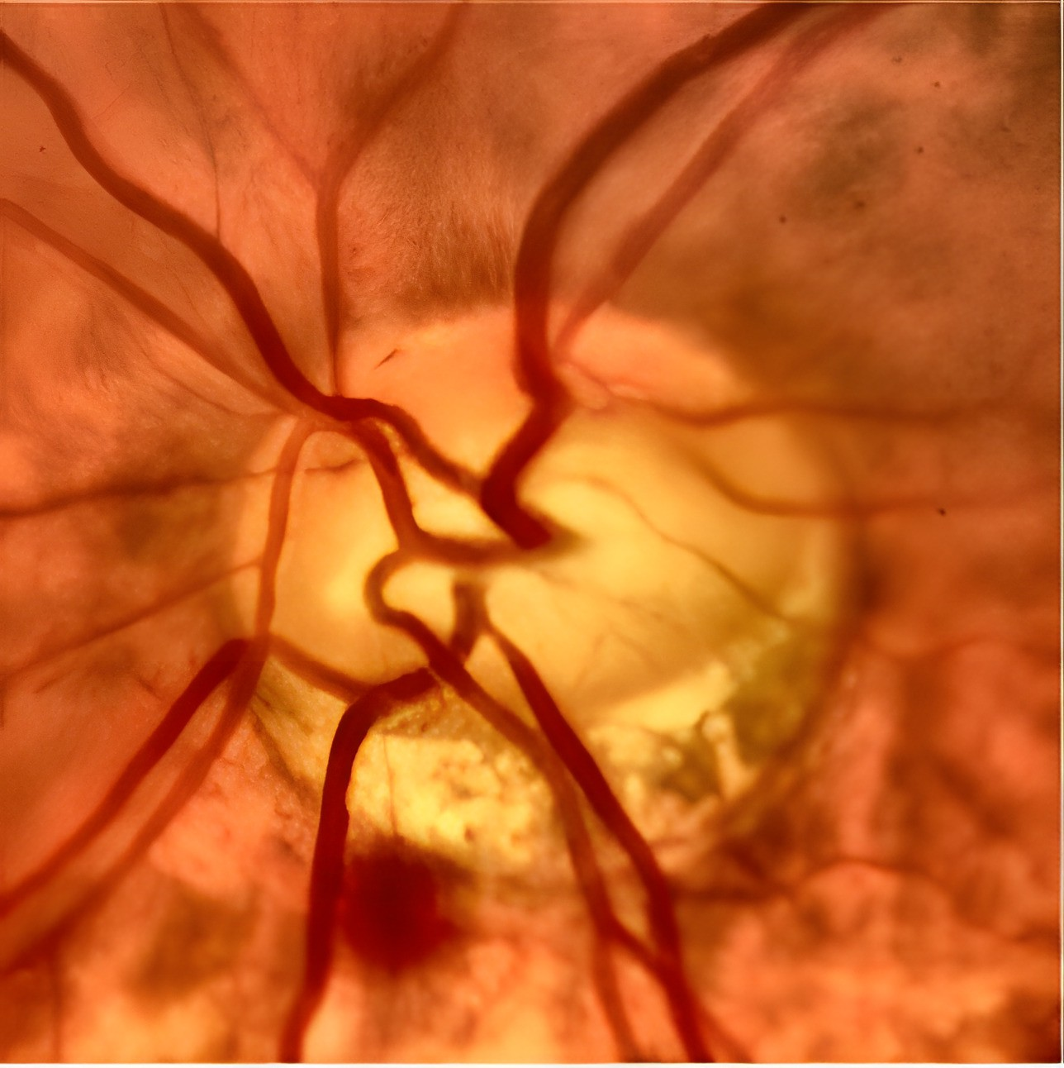 | 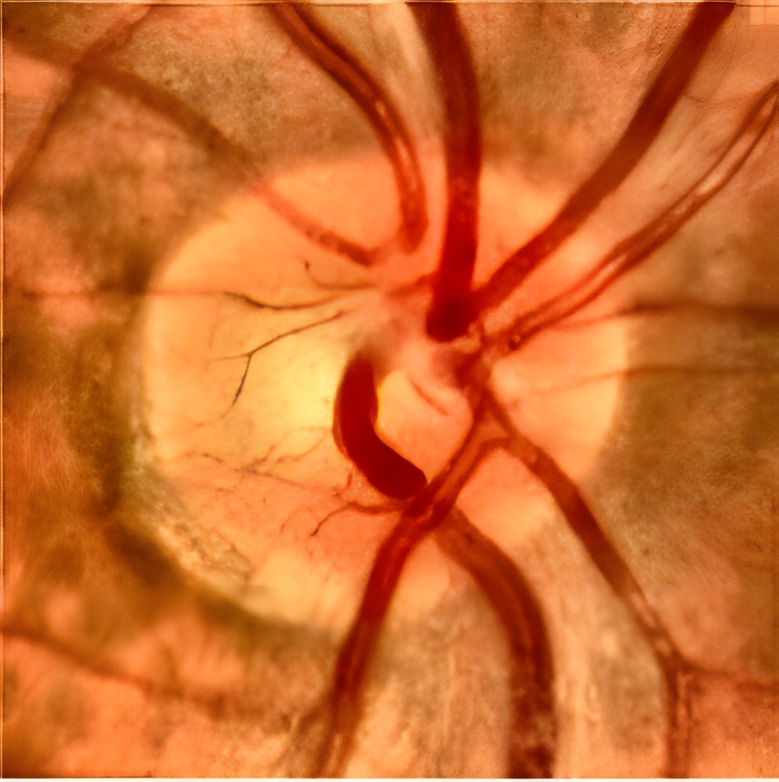
- Glaucoma Eye | - Normal Eye
Figure 1.1 Structural Differences Between Normal and Glaucomatous Eyes
Figure 1.1 presents a comparative visualization of normal and glaucomatous retinal fundus images. Image (b) represents a healthy optic disc with a balanced cup-to-disc ratio. In contrast, image (a) exhibits characteristic glaucomatous features, including enlargement of the optic cup and thinning of the neuroretinal rim. These structural differences are essential indicators for glaucoma diagnosis.

1.2 Convolutional Block Attention Module
The Convolutional Block Attention Module (CBAM) is an efficient, versatile attention mechanism that can be incorporated into any Convolutional Neural Network (CNN) architecture. Enhances the network’s representational capacity by emphasizing sig- nificant features across both spatial and channel dimensions. CBAM is designed to enhance feature learning in CNNs by incorporating attention mechanisms that sequen- tially refine feature maps through channel and spatial attention.Therefore, CBAM prompts the network to pay more attention to the most informative features of the input, which, in turn, improves performance in general. In terms of its structure, CBAM combines two attention mechanisms, channel attention and spatial attention [19], as illustrated in Figure 1.2. These mechanisms have been designed to improve feature representation by focusing attention on the most relevant part of it.

1.2.1 Channel attention module
This module focuses on “what” is meaningful given an input image by emphasizing important channels. At first input feature F passed through both average pooling and max-pooling layer and generate two different spatial context descriptors: F^{c}_{avg} and F^{c}_{max}, which denote average-pooled features and max-pooled features respectively. Then both descriptors are then sent to a shared network to create channel attention map M_{c} ϵ R^{C×1×1}. One hidden layer and a multi-layer perceptron (MLP) make up the shared network. The hidden activation size is set to R^{C/r×1×1} to reduce parameter overhead, where r is the reduction ratio. Then the shared network is applied to each descriptor, and it merge to the output feature vectors using element-wise summation, as illustrated in Figure 1.3. In short, it computed as:

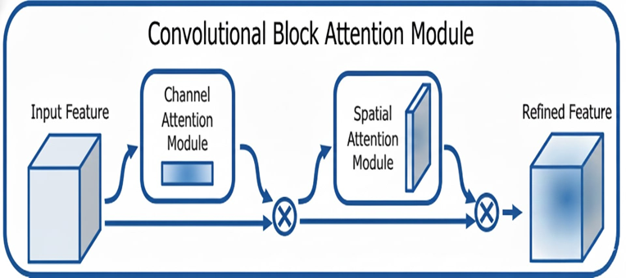
Figure 1.2 Convolutional Block Attention Module Architecture
Figure 1.2 presents the architecture of the Convolutional Block Attention Module (CBAM). The module consists of two sequential components: channel attention and spatial attention. Channel attention refines feature maps by emphasizing important channels, while spatial attention focuses on significant regions within the feature map.
$$M_{c}\left(F\right)=σ\left(MLP\left(AvgPool\left(F\right)\right)+MLP\left(MaxPool\left(F\right)\right)\right), (1) \\ =σ\left(W_{1}\left(W_{0}\left(F_{avg}^{c}\right)\right)+W_{1}\left(W_{0}\left(F_{max}^{c}\right)\right)\right)$$
where σ denotes the sigmoid function, W₀ ϵ R^{C/r×C}, and W₁ ϵ R^{C×C/r}. Here the MLP weights, W₀ and W₁, are shared for both inputs and the ReLU activation function is followed by W_{0.}

1.2.2 Spatial Attention Module
This module focuses on ‘where’ is an informative part located on images. To compute the spatial attention, at first average-pooling and max-pooling operations are apply on the output of channel attention module and generating two 2D maps: F_{s} ϵ R^{1×H×W} and F_{s} ϵ R^{1×H×W}. These are denoted as average-pooled features and max-pooled features across the channel. Then they are concatenated and convolved by a standard convolution layer, producing 2D spatial attention map, as illustrated in Figure 1.4. In short, the spatial attention is computed as:
$$M_{s}\left(F\right)=σ\left(f^{7×7}\left(\left[AvgPool\left(F\right);MaxPool\left(F\right)\right]\right)\right), (2) \\ =σ(f^{7×7}\left({[F}_{avg}^{s};F_{max}^{s}\right])),$$
where σ denotes the sigmoid function and f ^{7×7} represents a convolution operation with the filter size of 7 × 7.
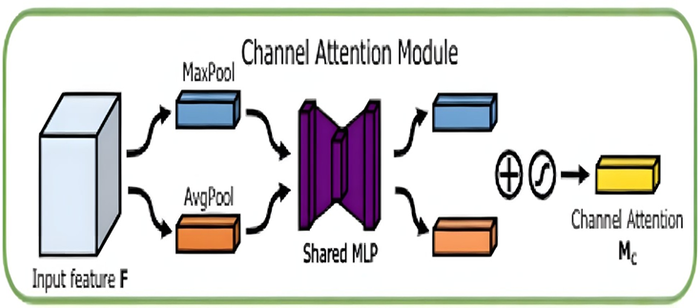
Figure 1.3 Channel Attention Module
Figure 1.3 presents the structure of the Channel Attention Module. It enhances feature representation by identifying and emphasizing the most informative channels in the input feature map through global average and max pooling operations followed by shared fully connected layers. The generated channel attention weights are multiplied with the original feature map to strengthen important features and suppress irrelevant information.
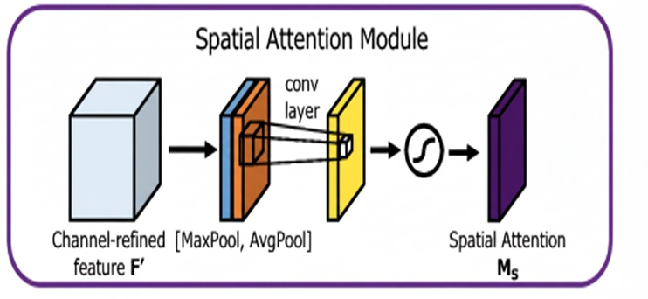
Figure 1.4 Spatial Attention Module
Figure 1.4 shows the structure of the Spatial Attention Module. It focuses on highlighting important spatial regions within the feature map by applying average and max pooling across channels, followed by a convolution operation. The resulting spatial attention map is multiplied with the input feature map to enhance relevant regions and suppress less important areas.
Computer Aided Diagnosis (CAD) systems have emerged as an effective and objective approach to the early detection of glaucoma using images of the retinal fundus [4]. Still, in previous years, the major approaches in CAD systems were based on conventional image analysis and conventional machine learning methods using manually engineered features like optic cup to disk ratio and texture features. Although these approaches led to some success, they still faced challenges in terms of generality when faced with different imaging conditions and patient variations. Recently, deep learning methodologies, especially convolutional neural networks (CNNs), have been widely established in the field of automated glaucoma identification due to their capacity to automatically discover features from the data. Many approaches based on CNNs have led to some success in differntiating glaucomatous eyes from normal eyes successfully [5, 6].
However, some challenges still exist. Many existing methods depend on very deep networks, multi-stage pipelines, or additional preprocessing steps such as explicit optical disk segmentation [7] or multimodal data fusion [8]. These designs often increase computational complexity, require extra annotation, and limit practical deployment in a real-world screening environment. It remains an open challenge to achieve high diagnostic accuracy while maintaining model efficiency and simplicity.
Following these limitations, the current study proposes a lightweight deep learning framework based on EfficientNetB0 integrated with a custom-designed Convolutional Block Attention Module for automated detection of glaucoma from fundus images. The key novelty of the proposed approach is to modify the spatial attention of CBAM by incorporating the standard deviation pooling operation in addition to Conventional average and max pooling. This enhancement enables the attention mechanism to stress subtle patterns related to glaucoma, such as optic disk cupping, neuroretinal rim thinning, and localized texture changes, that might get unnoticed by a conventional first-order standard mechanism. Few studies have investigated the incorporation of second-order statistical pooling in CBAM-based spatial attention for glaucoma detection. Considering the compound scaling strategy and MBConv blocks [9], the EfficientNetB0 employed in the proposed model is highly lightweight and suitable for practical deployment.
The contributions of this work can be summarized as follows:
- The proposed CNN-based glaucoma detection framework makes use of the Effi- cientNetB0 model integrated with a Customized CBAM attention module. Custom spatial attention incorporates standard deviation pooling into the original CBAM design, improving sensitivity to features related to glaucoma.
- A comprehensive evaluation, including ablation studies, is conducted to analyze
the impact of different CNN backbones and attention mechanisms, confirming the effectiveness of the proposed Customized CBAM The remainder of this paper is organized as follows.
Section II reviews related work on deep learning based glaucoma detection. Section III describes the materials and methods used in this study. Section IV presents the experimental results and discussion. Finally, Section V concludes the article.

Chapter 2. Literature Review
Deep learning techniques, especially CNN, have recently been widely used in auto- mated glaucoma detection, because these models are capable of learning relevant visual features by themselves from the given retinal images. The majority of the early work on glaucoma detection was based on traditional image processing and machine learning techniques with handcrafted features. These features usually showed poor performance with respect to illumination variations, noise, and generalization across datasets. Recently, end-to-end deep CNN models have largely outperformed tradi- tional methods in performance. Here we summarize several representative studies in the literature.
Chang et al. [10] developed a system for the detection of glaucoma. Their system involved a comprehensive preprocessing of glaucoma and OCT images to produce better results, followed by a fundus to OCT image generation phase to exploit multiple imaging modalities. Afterward, glaucoma classification involved using CNN based on the VGG19 model. They also applied incremental learning to gradually adapt the model to variations in image quality from different clinical environments. Their model proved the necessity of data augmentation along with continuous learning.
Lenka et al. [11] introduced a multi-task learning framework using a combination of CNNs and Graph Convolutional Networks (GCNs). In their method, fundus images undergo preprocessing and feature extraction via MobileNetV2; then a graph-based representation of the anatomical structure is constructed so that a GCN can learn from both the image features and their spatial relationships. In an attempt to improve generalization, the model also includes an attention mechanism and a support decoder for optic disk segmentation and recovery, achieved via a multi-task approach.
Patil and Sharma [12] investigated the use of transfer learning for glaucoma detection and demonstrated notable improvements in binary classification performance. Their approach involved replacing the top layers of several pre-trained convolutional neural networks such as DenseNet169, MobileNet, InceptionV3, ResNet152V2, VGG19, and Xception after applying standard preprocessing and data augmenta- tion techniques to fundus images. Their approach demonstrated the advantages of using pretrained models for small medical image datasets by successfully differentiating between glaucomatous and healthy eyes using global average pooling and fully-connected layers.
Agboola and Zaccheus [13] proposed a method based on wavelet image scattering for the detection of glaucoma. Instead of resorting to the use of deep CNNs, a Wavelet Image Scattering Network (WISN) was employed for the purpose of feature extraction. This network utilizes 2D Morlet wavelet filters. The scattering coefficients obtained from this process are employed for the purpose of classification using simple classifiers like Support Vectors Machines (SVMs) and logistic regression. This seems like a good approach to implement classification tasks. However, the accuracy of classification might be impacted for large image databases.
Yi et al. [8] developed a multimodal deep learning architecture for the classification of glaucoma severity by combining fundus photographs with the corresponding visual field exam data. Their method first reconstructed low-resolution visual field grayscale images to a higher resolution, then fused this with the fundus image. The fused inputs were fed into CNN backbones (VGG19, SqueezeNet, ResNet50, DenseNet121) to extract features. For capturing global dependencies which CNNs are not capable of handling, they used a Vision Transformer-based Multi-Layer Perceptron (MLP) in replacement of the standard classifier. This was beneficial in their classification tasks related to glaucoma among four stages based on structural (image) and functional (visual field) data.
Norouzifard et al. [14] focused on the optic nerve head region. They developed an automated system where the optical disk region is first cropped from fundus images as a preprocessing step. These optical disk-centered images were then used to fine-tune CNN models (pre-trained on VGG19 and Inception ResNet-V2 ImageNet) in order to identify glaucomatous patterns. Focused on the head of the optic nerve, the model allows it to better capture critical factors, suggesting that better performance can be ensured when important areas are isolated.
Yu et al. [7] also emphasized how crucial the localization of the region-of-interest is. They used a two-stage method-first segmenting the optical disk using a deep model to identify the region of interest, and then feeding the cropped disk region into a CNN classifier to distinguish between glaucoma and normal. Their findings have shown that accurate optic disk segmentation as a pre-processing step can further improve the performance of glaucoma classification downstream.
In general, these studies use different techniques to recognize glaucoma: customized preprocessing, transfer learning with different CNN architectures, multimodal inputs, attention processes, even hybrid CNN-GCN or wavelet methods. Although they report a high degree of precision in distinguishing between patients with glaucoma and healthy eyes, it remains problematic to compare them directly due to variations in datasets and evaluation procedures. Contrary to many prior studies that involve com- plex heavy architectures or specialized preprocessing (for example, manual region cropping or generating synthetic data), our approach focuses on a lightweight model that is reinforced by a unique attention mechanism. We aim to obtain competitive or higher accuracy with fewer parameters by combining EfficientNetB0 with a modified CBAM so that the need for complex multi-model data and manual engineering of features is dispensed with.

Chapter 3. Research Methodology
The methodology of the proposed study follows a structured pipeline that is designed appropriately to identify glaucoma from fundus images of the retinal part of the eye efficiently and accurately. Data Collection is the first stage where the required high quality fundus images are taken from the publicly available datasets. Data Preprocess- ing follows next, where the images are processed to create favorable input conditions for the model. Deep features are extracted using multiple convolutional neural network (CNN) backbones, and the feature maps are then put into a customized Convolutional Block Attention Module (CBAM) for further spatial and channel wise representations. Finally, refined features are used to classify the input data to produce the diagnostic result. The complete workflow is presented in Figure 3.1.
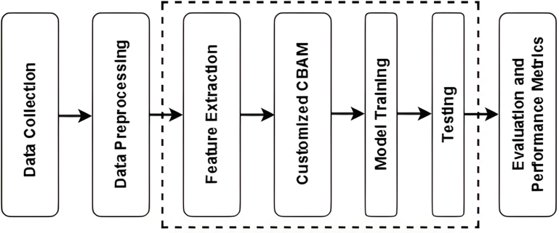
Figure 3.1 Proposed Glaucoma Detection Model Pipeline
Figure 3.1 presents the proposed glaucoma detection model pipeline. The workflow begins with data collection, followed by preprocessing to prepare the images for analysis. Features are then extracted and passed through the customized CBAM module to enhance important spatial and channel information. Finally, the processed features are used for model training, testing, and evaluation using standard performance metrics.

3.1 Dataset
We evaluated the proposed method on two publicly available glaucoma datasets: ACRIMA and LAG, obtained via a Kaggle repository of glaucoma classificationdatasets. The ACRIMA dataset consists of fundus images labeled as glaucomatous or healthy, with a total of 705 images (396 glaucoma, 309 healthy) [dataset originally introduced by the ACRIMA project]. The LAG (Large-scale Attention-based Glau- coma) dataset has a collection of 4,854 fundus images (1,711 glaucoma images and 3,143 normal images), each of which has been carefully labeled by experts. In con- ducting our experiments, we followed the same splits proposed in the original source, Kaggle, of about 80% for the training phase and the remaining 20% for the testing phase. In the ACRIMA dataset, this means that we will be using 317 glaucoma images and 247 normal images for training and another 79 glaucoma images and 62 normal images for testing. In LAG, about 1,369 glaucoma and 2,514 healthy images were used for training, and 342 glaucoma and 629 healthy images for testing. In Table 3.1 the features of the data set are compiled, such as the number of photos for each class in the training and testing divisions. Because both datasets are openly accessible, our findings are easier to replicate.

3.2 Preprocessing
All images went through a preprocessing stage to improve quality and standardize the input to CNN. First, a standard resolution of 256x256 pixels (with three color channels:
Table 3.1 Summary of Used Dataset
Name | Glaucoma | Healthy | Training |  | Testing |  | Availability
Name | Glaucoma | Healthy | Glaucoma | Healthy | Glaucoma | Healthy | Availability
ACRIMA | 396 | 309 | 317 | 247 | 79 | 62 | Public
LAG | 1711 | 3143 | 1369 | 2514 | 342 | 629 | Public
Table 3.1 summarizes the ACRIMA and LAG datasets used in this study. It shows the number of glaucoma and healthy images, along with their respective train-test splits. Both datasets are publicly available and provide sufficient samples for training and evaluating glaucoma detection models.
RGB) was enforced on all fundus images to meet the requirements of CNN backbone architecture. This guaranties uniform image scales and dimensions through- out the data set. The images were converted from RGB to LAB color space, where the L channel represents luminance information, in order to enhance contrast and address illumination variations. Contrast Limited Adaptive Histogram Equalization (CLAHE) [18] was applied to only the L channel to reduce noise amplification and increase local contrast. A clip limit of 3.5 and a grid size of 8×8 were used. After contrast enhancement, the images were converted back to RGB color space. This process improves the visibility of important retinal structures, such as the optic disk and blood vessels. (Figures 3.2a and 3.2b in the original manuscript illustrate a sample image before and after preprocessing). Furthermore, we applied a data augmentation approach that aimed to improve the diversity within the training data set and prevent over-fitting. Each picture in the training data set is randomly transformed by applying horizontal and vertical flips, small rotations (up to ±10 degrees), translations or shifts within an area scaled down to 15% % of the actual image size, and minor contrast changes ranging from -10% to +10%. These transformations aim to reflect the differences that may arise during the image acquisition process conditions (such as the angle of the camera, the position of the eyes, and lighting), and thus help to enable generalization for the given model. Before the beginning of each training iteration for the model, the set was randomized to remove any abnormalities associated with the order. The addition of resizing, CLAHE image enhancement, and image augmentation techniques introduced more uniform and diverse images within the training set; we observed this technique to increase the robustness and accuracy of our glaucoma detection model.
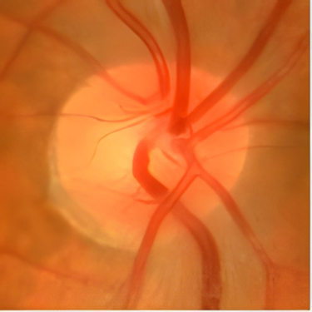 | 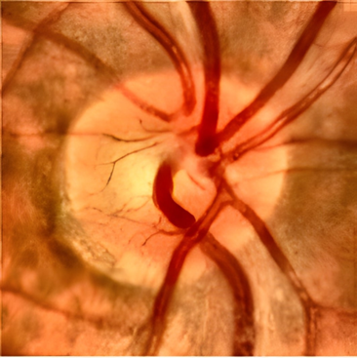
- Before Preprocessing | - After Preprocessing
Figure 3.2 Preprocessing of retinal Fundus Images
Figure 3.2 illustrates the effect of preprocessing on retinal fundus images. Image (a) shows a raw retinal image with noise, uneven illumination, and low contrast. Image (b) presents the same image after preprocessing, where noise is reduced, contrast is enhanced, and the image is normalized for further analysis. Preprocessing improves the quality of input data, facilitating more accurate feature extraction and model performance.

3.3 Deep Feature Extraction with CNN Backbones
After preprocessing, the next step is to extract high-quality features from the retinal images capturing anatomical and pathological cues of glaucoma. Due to the fact that the publicly available datasets related to glaucoma are relatively small and the disease indicators may be subtle, the selected feature extractor should possess both strong gen- eralization capability and sensitivity to fine-grained patterns. To this end, we employed several state-of-the-art convolutional neural network architectures as backbone mod- els for deep feature extraction. In this regard, five CNN models in different levels of complexity were tested: including EfficientNetB0, ResNet50, MobileNetV2, Xception, and DenseNet121. These models offer complementary strengths in terms of network depth, connectivity patterns, and parameter efficiency. The network was trained with weights that had been pretrained on ImageNet to take advantage of learned low-level image features and facilitate fast convergence because of the relatively small size of our data. The output feature maps produced by these backbones were used as inputs to the attention module and classifier of our network. In this section, we give a brief description of each of these backbones and their relation to our task:

3.3.1 EfficientNetB0
EfficientNetB0 [9] is a greatly optimized CNN model that reaches excellent accuracy at a relatively-low parameter count using compound scaling. It uniformly scales network depth, width, and input resolution according to predefined coefficients. EfficientNetB0 is built from a series of MBConv blocks (mobile inverted bottleneck convolutional blocks with squeeze-and-excitation) as illustrated in Figure 3.3. Each MBConv block consists of an expansion phase, a depthwise separable convolution, a squeeze-and- excitation (SE) channel attention, and a projection phase. The EfficientNetB0 design balances these dimensions (depth d, width w, and resolution r) such that a small base model can be scaled up efficiently: for scaling factor ϕ, depth ≈ αϕ, width ≈ βϕ, and resolution ≈ γϕ, under the compound constraint α · β2 · γ2 ≈ 2 (as derived in [9]). This careful design allows EfficientNetB0 to extract multi-scale and fine-grained features while keeping computational cost low. In the context of retinal fundus analysis, EfficientNetB0’s depthwise separable convolutions capture subtle vascular and texture patterns, and the integrated SE attention highlights important channels corresponding to glaucoma related features. Therefore, EfficientNetB0 ensures that highly discriminative feature embeddings are generated from fundus image inputs. This makes EfficientNetB0 suitable to be used as the backbone network.
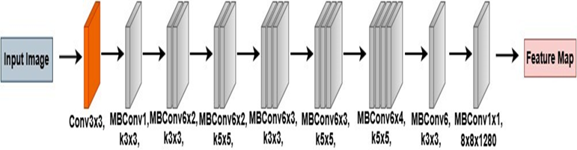
Figure 3.3 EfficientNetB0 Architecture
Figure 3.3 illustrates the EfficientNetB0 architecture used for feature extraction. The model applies a series of convolutional, and MBConv layers to extract discriminative features from input retinal images. These features are then passed to the subsequent CBAM module and classification layers for glaucoma detection.

3.3.2 ResNet50
ResNet50 [20] is a 50-layer deep CNN, which made its appearance by proposing resid- ual learning to facilitate the training of deep networks. The architecture is divided into four stages consisting of convolution layers, which in each stage, consists of sev- eral bottleneck residual layers as shown in Figure 3.4. A bottleneck block is composed of a 1 × 1 convolution for dimensionality reduction, a 3 × 3 convolution for the extraction of spatial features, and a 1 × 1 convolution for the expansion back to a higher channel dimension. The most important part in the ResNet is named the identity shortcut connection. The identity shortcut connection is adding the output of the block to the input. It can be expressed in the following equation: y= F(x) + x. In the represen- tation shown, F(x) is the output from the convolution layers and x is the input to the layer. By this mechanism, the vanishing gradient problem is avoided, as the resid- ual, not the function, is learned. In fact, the gradient through a residual block can be described by:
$$\frac{∂L}{∂x}=\frac{∂L}{∂y}\left(1+\frac{∂L}{∂x}\right), (3)$$
which shows that the gradient is strengthened by the skip connection (when ∂F ≈ 0, the gradient ∂L≈ ∂L , mitigating degradation in very deep models). For glaucoma detection, ResNet50’s deep architecture and residual design are advantageous because they enable learning both low level features (e.g., blood vessel patterns, texture of the retinal nerve fiber layer) and high-level features (overall optic disc cupping, shape deformations) across various spatial scales. The high propagation of features within the ResNet50 model guarantees that robust and discriminative representations are attained. It has been noticed that the embeddings are effective in different medical image processing tasks, including identifying changes within the optic disc caused by glaucoma.
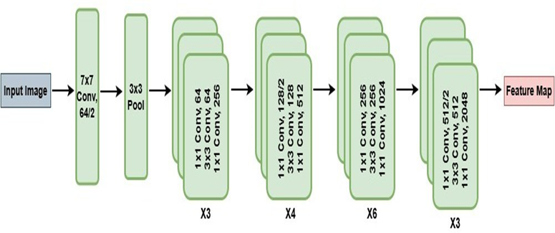
Figure 3.4 ResNet50 Architecture
Figure 3.4 shows the ResNet-50 architecture used for feature extraction. The model employs multiple residual blocks to learn deep feature representations while mitigating the vanishing gradient problem. Extracted features are then passed to the CBAM module and classification layers for glaucoma detection.

3.3.3 MobileNetV2
MobileNetV2 [21] is an efficient CNN architecture that is designed specifically for mobile and embedded systems, but it can be used efficiently in standard vision applications as well. It is composed of inverted residual blocks with linear bottlenecks, as illustrated in Fig 3.5. Each MobileNetV2 block first expands the input channels with a 1 × 1 convolution, then applies a depthwise 3 × 3 convolution (which filters each channel independently), and finally uses a 1 × 1 projection convolution to compress the output to a smaller set of channels (the bottleneck). The structure is called ”inverted” because it starts with expansion (as opposed to ResNet’s reduce-then-expand pat- tern). The residual connection in MobileNetV2 skips over the intermediate expanded representation and connects the bottleneck outputs (provided the input and output dimensions match). This model has strong parameter efficiency and does not involve non-linearities in the narrow part of the bottleneck (utilizing linear activation in that part) in order to retain data. MobileNetV2 can be efficiently applied in analyzing a retina because in this case, there are fine but important details (such as small vessel boundaries or textural variations) that require observation in a non-robust way but are unnecessary in the model’s complexity. The localized patterns in a retina that are represented in localized glaucoma injuries are modeled effectively by Bottlenecks help to retain the representational abilities while reducing computational complexity. Hence, MobileNetV2 is able to produce small but representative feature maps. Using MobileNetV2 will help to create real-time glaucoma diagnosis systems with a slightly less accurate outcome compared to other models.
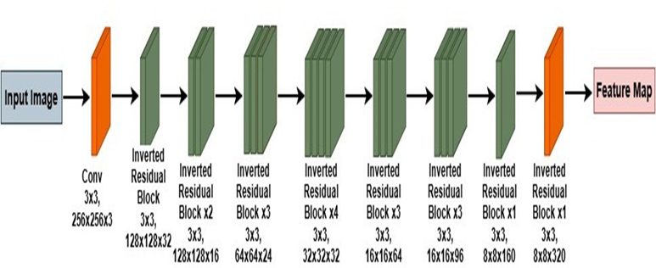
Figure 3.5 MobileNetV2 Architecture
Figure 3.5 illustrates the MobileNetV2 architecture used for feature extraction. The model uses inverted residual blocks with linear bottlenecks to efficiently capture features while reducing computational cost. Extracted features are then passed to the CBAM module and classification layers for glaucoma detection.

3.3.4 Xception
Xception [22] (Extreme Inception) is a CNN architecture that extends the idea of Inception modules by relying entirely on depthwise separable convolutions. It was later proposed by Chollet as an improved version of the InceptionV3 model, with the assumption that spatial and channel-wise correlations in the feature maps can be represented independently. The regular convolution in the Xception network can be considered as an operation divided into two steps: first, a depthwise convolution, also called spatial convolution, performed on each channel, and then a pointwise convolution, or 1 × 1 convolution, performed channel-wise. Mathematically, this can be expressed as Output = PWConv(DWConv(Input)) , which allows the network to learn spatial features and channel relationships separately. The Xception architecture is structured into an Entry Flow, Middle Flow, and Exit Flow with a total of 36 convolutional layers, and it uses residual connections around these flows for ease of training as illustrated in Figure 3.6. This design makes Xception very effective for image classification tasks: the depthwise convolutions capture fine localized variations (e.g., optic disc boundary irregularities, vessel branching changes, RNFL texture changes) in each color channel, while the pointwise convolutions then integrate these findings across channels into more abstract features. The strength of Xception’s in channel- based pattern modelling is particularly relevant to fundus pictures, as several colour channels (such as red, green, and blue) can highlight distinct diseases or structures. By fully separating spatial and channel feature learning, Xception provides a powerful yet computationally efficient backbone for detecting subtle structural changes associated with glaucoma.
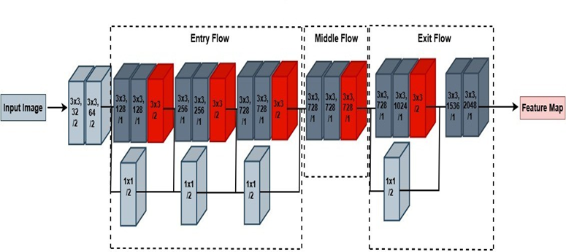
Figure 3.6 Xception Architecture
Figure 3.6 shows the Xception architecture used for feature extraction. The model employs depthwise separable convolutions to efficiently capture spatial and channel-wise features. Extracted features are then passed to the CBAM module and classification layers for glaucoma detection.

3.3.5 DenseNet-121
DenseNet121 [23] is another CNN network that has a dense connectivity architecture; that is, each layer takes all feature maps generated from the preceding layers. In DenseNet, with the number of layers being L, the output of the ℓ-th layer can be expressed as follows: x_{ℓ} = H_{ℓ}([x₀, x₁, ..., x_{ℓ−1}]), where [·] denotes the concatenation of feature maps and Hℓ() is the sequence of operations (batch norm, ReLU, convolution as illustrated in Figure 3.7) in layer ℓ. This characterizes DenseNet, where feature reuse has taken place, and there is a substantial reduction in the number of parameters due to the avoidance of redundant feature learning. DenseNet121 has four dense blocks with layer counts 6, 12, 24, and 16, respectively. The connections between the layers are transitions that facilitate downsampling and channel merge. Every layer generates a fixed number of feature maps (known as ”growth rate” and set to 32) that are added to the cumulative set of feature maps. In effect, the output will have C_{out} = C_{in} + L_{k} feature channels is robust against vanishing gradients. In retinal image analysis, the reusage of features in the DenseNet is helpful to recognize delicate patterns like tiny changes in optic disc appearance or peripapillary nerve fiber layer striations in glaucoma. By passing these delicate features through multiple layers, the DenseNet121 is able to form intricate aggregations of features to identify normal and glaucomatous eyes. Also, the efficiency of the DenseNet121 (having fewer parameters for the same depth) enables us to employ a deep architecture to abstain from overfitting, which is helpful in our case. Also, the feature extraction capability of the DenseNet121 is quite good along with its optimum balance of depth and efficiency of parameters, which makes it a good selection as the base in our glaucoma diagnosis system.
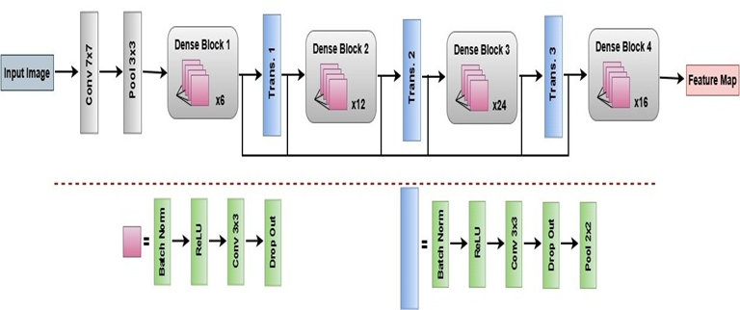
Figure 3.7 DenseNet-121 Architecture
Figure 3.7 illustrates the DenseNet-121 architecture used for feature extraction. The model connects each layer to every other layer in a feed-forward fashion, enabling efficient feature reuse and improved gradient flow. Extracted features are then passed to the CBAM module and classification layers for glaucoma detection.

3.4 Proposed Model Architecture with Customized CBAM
Our glaucoma detection model adopts a hybrid architecture that combines one of the CNN backbones described above with a customized Convolutional Block Attention Module (CBAM) inserted to refine the features, followed by a classifier. Figure 3.8 in the original paper illustrates the customized CBAM design. In general, a standard CBAM [19] applies attention sequentially in two dimensions: channel and spatial. After the CNN backbone extracts initial feature maps F ∈ RH×W ×C (height H, width W , C channels), the CBAM processes them as follows:
• Channel Attention: The goal of channel attention is to infer which feature chan- nels are the most relevant (“what” features to focus on). We pass F through both a global average pooling and a global max pooling operation (each pooling operates across the spatial dimensions H × W for every channel). This produces two descriptors of size 1 × 1 × C: the average-pooled vector Fc and the max-pooled vector Fcmax. These two descriptors are then fed into a shared two-layer fully connected network (a multilayer perceptron, MLP, with one hidden layer) to generate an attention score for each channel. The MLP’s weights are shared for the two descriptors. Let W0 and W1 be the weight matrices of the first and second layer of this MLP (with a ReLU activation after W₀). Typically, a reduction ratio r is used in the hidden layer to reduce parameters (so W₀ has dimension $C×\frac{C}{r}$ and W₁ is $\frac{C}{r}×C$). The outputs of the MLP for the average and max descriptors are then summed element wise and passed through a sigmoid (σ) to produce the final channel attention map Mc(F ) of size 1 × 1 × C. This can be expressed as:

$$M_{c}\left(F\right)=σ\left(MLP\left(F_{avg}^{c}\right)+MLP\left(F_{max}^{c}\right)\right)=σ\left(W_{1}\left(W_{0}\left(F_{avg}^{c}\right)\right)+W_{1}\left(W_{0}\left(F_{max}^{c}\right)\right)\right), (4)$$
where σ(·) is the sigmoid activation. The resulting attention map Mc has a separate weight in [0,1] for each channel, indicating the importance of each feature channel. The input feature maps are then multiplied by Mc (channel-wise multiplication) to yield F′ = Mc(F ) ⊗ F , which is the attention-weighted feature map after channel refinement.
• Spatial Attention: After channel attention, the refined feature F′ is used for spatial attention (finding “where” the important features are spatially). In the standard CBAM, spatial attention is computed by applying pooling across the channel dimension. Specifically, two 2D maps are obtained by average pooling and max pooling along the channels of F′ (resulting in Fs ∈ RH×W×1 and Fs ∈ RH×W ×1). These two single-channel maps are concatenated to form a two-channel 2D image, which is then convolved with a 7×7 filter followed by a sigmoid to produce the spatial attention map Ms(F ′) ∈ RH×W ×1. In formula form, standard spatial attention is:
$$M_{s}\left(F^{''}\right)=σ\left(f^{7×7}\left(\left[F_{avg}^{c};F_{max}^{c}\right]\right)\right), (5)$$
where [ ; ] denotes channel-wise concatenation and f7×7 is a 7×7 convolutional layer. The output Ms assigns an attention weight to each spatial location (pixel) in the feature map, indicating which regions are likely to contain important information.
Finally, the spatial attention map is applied to F′ (element-wise multiplication across the H × W spatial grid for all channels) to yield the final attended feature F ′′ = Ms(F ′) ⊙ F′.

In our Customized CBAM, we keep the channel attention unchanged as in the original CBAM, while customizing the spatial attention module by incorporating an extra pooling process to extract information of the second-order statistic. That is, besides performing the average and max pooling across channels, we also conduct standard deviation pooling. The thought behind it is that areas with high variance in intensity values or features can perhaps point to meaningful structures or disease patterns (e.g., the border of the optic cup can have high variance in features or textural areas can have varied standard deviation). By adding the standard deviation component, the attention mechanism can make proper use of the contrast information between textures provided by the average or max values. Mathematically, let F′ ∈ R^{H×W×C} be the feature map after channel attention. For each spatial location (i, j), we compute three pooled values across the C channels: the average F_{avg}(i, j), the maximum F_{max}(i, j), and the standard deviation F_{std}(i, j). These are defined as:
$$F_{i,j}^{avg}=\frac{1}{C}\sum_{c=1}^{C}{F_{i,j,c}^{'}, F_{i,j}^{max}=\max_{1≤c≤C}{F_{i,j,c}^{'}, F_{i,j}^{std}=√(\frac{1}{C}\sum_{c=1}^{C}{{\left(F_{i,j,c}^{'}-F_{i,j}^{avg}\right)}^{2}), (6)}}}$$
These three H × W maps F_{avg}, F_{max}, and F_{std} are then concatenated along the channel dimension to form a three-channel 2D feature (essentially stacking the three statistical maps). We apply a convolution with a 7 × 7 kernel across this three-channel input and then a sigmoid activation to generate the spatial attention map Mcustom:
$$M_{s}^{custom}\left(F^{'}\right)=σ(f^{7×7}([F^{avg};F^\max{;F^{std}])), (7)}$$
where f^{7×7} now has a three-channel input and 1-channel output. By including F_{std}, this modified spatial attention can respond to regions where feature values have high variance, capturing textural and contrast variations not evident from just the mean or max. After obtaining M_{custom}, we multiply it with F′ to yield the final attention refined feature maps F ′′ = M_{custom}(F ′) ⊙ F′. This F ′′ is then passed through into the classification layers.
Classification Layer: After the CBAM attention module, a global average pooling function is applied along the spatial axes to F ′′ to transform the feature maps to a 1D feature vector as illustrated in Figure 3.9. After this, a fully connected layer (dense layer), with 256 units and a rectified linear unit (ReLU) activation function, is added to produce a high-level feature representation based on the pooled features. A dropout layer, with a dropout rate of 0.5, is added before the dense layer to fight overfitting during training. A softmax output layer with 2 neurons is added to determine the two classes, namely glaucoma and healthy, and the class with a higher probability is predicted by the model.
Loss Function and Optimization: The training of the model is done end to end using the Adam optimizer (Adaptive Moment Estimation) with a learning rate of 1 × 10−4. The loss function used is sparse categorical cross-entropy, which is suitable because we are performing binary classification (where glaucoma is class 1 and healthy is class 0). The classification accuracy is used as a metric during training sessions.

3.5 Implementation Details
We developed the proposed model for glaucoma detection using Python with TensorFlow and Keras libraries in the Google Colab environment coupled with the GPU (Tesla T4 by NVIDIA) that greatly accelerates deep learning model training processes when dealing with images. These were some of the most important implementation aspects:
Framework and Libraries: TensorFlow/Keras has been utilized for creating the neural network. For image preprocessing, both OpenCV and the scikit-image library were used. For the manipulation of data and calculation of the value for evaluation, both NumPy and the scikit-learn library were employed.
Training Procedure: Feeding the training images into the network in mini-batches of size 32 after preprocessing and augmentation, we train for 20 epochs on each dataset, which is sufficient for convergence given transfer learning from ImageNet weights. We set aside 15% of the training set as a validation set to track the progress of training and tune hyperparameters. Early stopping is employed such that if the validation loss does not improve in a certain number of epochs, training would be stopped to prevent overfitting. We used an initial learning rate of $1×{10}^{-4}$ for Adam optimizer (with default β1=0.9, β1=0.999). The dropout rate in the classifier dense layer was 0.5 (50% dropout). A fixed random seed was used to initialize weights and to shuffle data in order to ensure reproducibility of results.
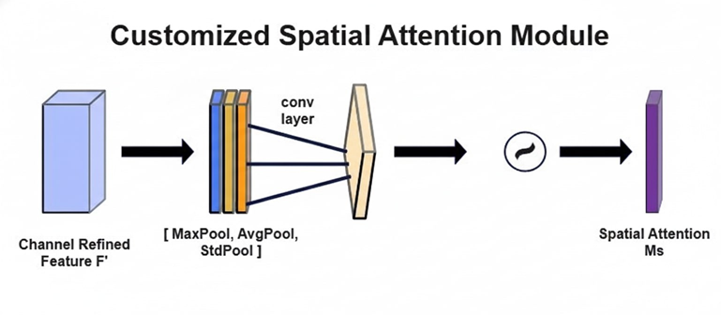
Figure 3.8 Customized Spatial Attention Module
Figure 3.8 illustrates the customized spatial attention module used in the proposed model. Unlike the standard spatial attention module, it incorporates a standard deviation pooling layer along with average and max pooling to capture feature variability across spatial locations. The resulting spatial attention map emphasizes important regions and suppresses less informative areas, enhancing feature representation for subsequent model processing.
Transfer Learning: The convolutional network architecture (EfficientNetB0 or other architectures) was initialized using weights trained on the ImageNet, which aided in faster convergence of the model and better results despite the limited amount of data used to train the model. In contrast to training from scratch, we discovered in our experiments that using pretrained weights greatly increased accuracy. The customized CBAM layers (which are not standard in ImageNet models) were initialized randomly and learned from scratch on the glaucoma task.
Hardware and Runtime: All experiments ran on the Colab GPU runtime. Each epoch of training on the ACRIMA dataset took only a few seconds (owing to its small size), while LAG, being larger, took a bit longer per epoch. In summary, the training of the 20 epochs on LAG using the EfficientNetB0+CBAM model took a few minutes. Generally, the final trained model is lightweight and takes less than a second to make predictions for individual images.
Moving on, now that our models have been trained, it is time for evaluation on the test datasets and their comparison with other methods, as explained in the following section.
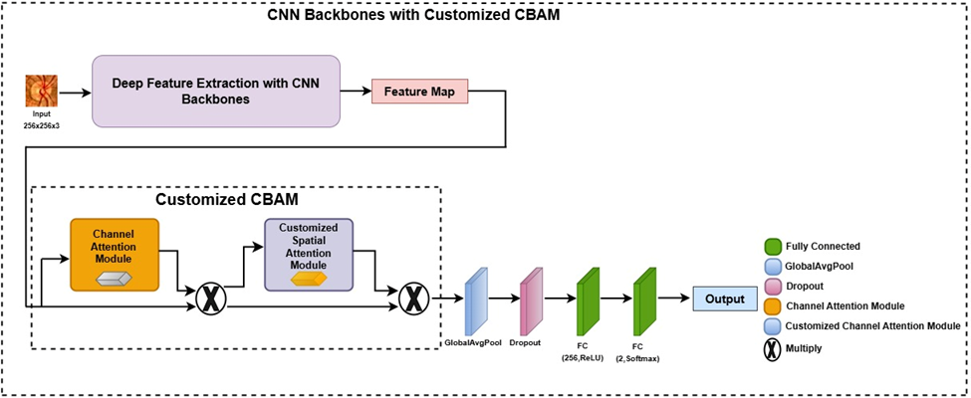
Figure 3.9 Proposed Method with Classification layer
Figure 3.9 shows the classification layer of the proposed model. Output from the customized CBAM module are first processed through a global average pooling layer, followed by dropout for regularization. The resulting vector is passed through a fully connected layer with 256 neurons and ReLU activation, then a final fully connected layer with 2 neurons and softmax activation to produce the output probabilities for normal and glaucomatous classes.

Chapter 4. Result and Discussion
In this section, we present the experimental results of our glaucoma detection model and analyze its performance. In this paper, we evaluate our model’s performance on the test sets of ACRIMA and LAG datasets regarding its accuracy, precision, recall/sensitivity, and F1-score. The performances on different models with different attention module variants are also included to verify our proposed solution’s benefit. In this paper, we evaluate our model’s performance on the test sets of ACRIMA and LAG datasets regarding its accuracy, precision, recall/sensitivity, and F1-score.
The performances on different models with different attention module variants are also included to verify our proposed solution’s benefit. For the purpose of glaucoma detection, TP refers to true positives (patients identified as glaucoma when in fact they are), while TN correspond to true negatives (patients identified as not having glaucoma when they are not), FP refer to those that are not glaucoma but test positive (patients identified as glaucoma when in fact they are not), and FN correspond to patients that are glaucoma but test negative (false negative). The goal is to maximize all these metrics, however in a real-world medical context where false negative findings are a concern (FN), sensitivity is quite significant and therefore minimized. High precision is also a significant goal in an application where patients are not wrongly classified as glaucoma when in fact they are not (which can cause unnecessary stress), since unnecessary testing is avoided in a definite manner if patients are not classified as glaucoma even when they are not glaucoma.

4.1 Performance with Different CNN Backbones and Attention Modules
We first evaluate the effectiveness of the proposed approach by comparing several configurations of backbone CNNs and attention modules on the classification task. We evaluated each of the five CNN backbones (EfficientNetB0, ResNet50, MobileNetV2, Xception, and DenseNet121) in three cases: (i) No Attention (the standard CNN model without any use of CBAM), (ii) Standard CBAM (the original CBAM model [19] added after the CNN feature extractor), and (iii) Customized CBAM (the proposed modified model with standard deviation pooling added after the CNN feature extractor). The models were trained and evaluated in exactly the same manner on both datasets. The results are shown in Table 4.1 and Table 4.2 below, and include the metrics of accuracy, precision, F1-score, and recall achieved in each configuration by each CNN model.
From table 4.1 and 4.2, the following observations have been made:
Baseline CNN performance: The model with the highest accuracy among the five CNN backbones without the attention mechanism was EfficientNetB0 with a result of 92.20% for the ACRIMA dataset and 90.94% for the LAG dataset. What it implies is that EfficientNetB0 can be a suitable model for basing the task most likely due to the impressive feature representation in terms of compound scaling. Although the other two architectures, namely Xception and MobileNetV2, relatively performed worse, most of the baselines, namely ResNet50 and DenseNet121, performed adequately well. This could be due to the latter two’s inability to capture certain fine retinal features or their lack of depth.
Impact of Customized CBAM: Our proposed modified CBAM further increased performance across the board. EfficientNetB0 + Customized CBAM specifically produced the highest performances of 98.58% accuracy, 98.75% F1, and 100% recall for ACRIMA, as
Table 4.1 CNN Backbone Performance on ACRIMA Dataset
Model | Accuracy | Precision | F1-Score | Recall
ResNet50 | 90.78 | 91.25 | 91.82 | 92.41
DenseNet121 | 89.36 | 89.02 | 90.68 | 92.41
Xception | 86.52 | 86.59 | 88.20 | 89.87
MobileNetV2 | 86.52 | 92.86 | 87.25 | 82.28
EfficientNetB0 | 92.20 | 92.50 | 93.08 | 93.67
ResNet50+CBAM | 92.91 | 92.59 | 93.75 | 94.94
DenseNet121+CBAM | 91.49 | 91.36 | 92.50 | 93.67
Xception+CBAM | 87.94 | 87.80 | 89.44 | 91.14
MobileNetV2+CBAM | 88.65 | 93.15 | 89.47 | 86.08
EfficientNetB0+CBAM | 95.04 | 95.00 | 95.60 | 96.20
ResNet50+Customized CBAM | 95.74 | 95.06 | 96.25 | 97.47
DenseNet121+Customized CBAM | 93.62 | 92.68 | 94.41 | 96.20
Xception+Customized CBAM | 90.78 | 90.24 | 91.93 | 93.67
MobileNetV2+Customized CBAM | 92.91 | 98.59 | 93.33 | 88.61
EfficientNetB0+Customized CBAM | 98.58 | 97.53 | 98.75 | 100.00

Table 4.1 compares the performance of different CNN backbones, with and without attention mechanisms, on the ACRIMA dataset. Metrics include Accuracy, Precision, F1-Score, and Recall. The results indicate that adding the customized CBAM module improves performance, with EfficientNetB0 + Customized CBAM achieving the highest accuracy and perfect recall
Table 4.2 CNN Backbone Performance on LAG Dataset
Model | Accuracy | Precision | F1-Score | Recall
ResNet50 | 87.74 | 83.69 | 82.32 | 80.99
DenseNet121 | 86.51 | 81.87 | 80.53 | 79.24
Xception | 82.39 | 75.83 | 74.59 | 73.39
MobileNetV2 | 84.65 | 78.81 | 77.99 | 77.19
EfficientNetB0 | 90.94 | 86.49 | 87.25 | 88.01
ResNet50+CBAM | 91.56 | 88.01 | 88.01 | 88.01
DenseNet121+CBAM | 88.26 | 84.34 | 83.09 | 81.87
Xception+CBAM | 86.17 | 79.29 | 78.82 | 78.36
MobileNetV2+CBAM | 86.71 | 82.18 | 80.83 | 79.53
EfficientNetB0+CBAM | 93.10 | 90.09 | 90.22 | 90.35
ResNet50+Customized CBAM | 93.51 | 93.39 | 90.72 | 90.06
DenseNet121+Customized CBAM | 91.76 | 88.99 | 88.20 | 87.43
Xception+Customized CBAM | 86.92 | 82.28 | 81.19 | 80.12
MobileNetV2+Customized CBAM | 89.08 | 85.12 | 84.37 | 83.63
EfficientNetB0+Customized CBAM | 96.09 | 94.97 | 94.41 | 93.86

Table 4.2 presents the performance of different CNN backbones, with and without attention mechanisms, on the LAG dataset. Metrics reported include Accuracy, Precision, F1-Score, and Recall. The results show that incorporating the customized CBAM module improves model performance, with EfficientNetB0 + Customized CBAM achieving the highest accuracy and overall performance for glaucoma detection.
well as 96.09% accuracy, 94.41% F1, and 93.86% recall for LAG. Note that the recall of 100% implies the model has successfully detected all glaucoma in the test dataset, which is highly desirable in a screening application. This is a marked improvement over normal CBAM as well as non-attentive CBAM. We attribute these gains to the inclusion of the standard deviation feature in the attention mechanism, allowing the model to more effectively detect subtle texture differences and edge information that distinguish glaucoma (for instance, areas of the optic disc rim vs. cup might have distinct variance patterns).
Other backbones with Customized CBAM also improved relative to their standard CBAM counterparts. For instance, ResNet50 + Custom CBAM vs. ResNet50 + standard CBAM: accuracy improved from 92.91% to 95.74% on ACRIMA, and from 91.56% to 93.51% on LAG. Similar trends are seen for DenseNet121 and MobileNetV2. These results demonstrate that our attention module modification is beneficial regard- less of the base CNN, though the absolute performance still varies by backbone capability.
Best architecture choice: From the above evaluation, we chose to use Efficient- NetB0 with Customized CBAM as our final model because it always produced the highest performance results. This is because the combination of the high performance of feature extraction by EfficientNetB0 and the enhanced attention mechanism made it so that our final model is not only highly accurate but is also considerably smaller in comparison to other models such as ResNet50 or DenseNet121 because it has many less parameters than the other two. This makes the solution attractive for practical deployment.
In addition, we performed an ablation analysis by evaluating each backbone with and without attention. The results clearly indicate that the addition of attention (whether Standard or Customized) positively affected each metric in nearly every scenario, validating the importance of attention to the optic nerve head area and other discriminatory areas within the task of glaucoma image classification. Between the two attention methods, Customized CBAM was found to perform better than CBAM, validating the addition of the standard deviation pooling method. For instance, on LAG using EfficientNetB0, the addition of CBAM increased the accuracy from 90.94% to 93.10%, and further increased to 96.09% when Customized CBAM was used. We see similar patterns in precision and F1-score. The improvements are especially pronounced on the ACRIMA dataset, where the model might be nearing ceiling performance the Custom CBAM helped squeeze out the last gains to reach 98–100% on some metrics.

4.2 Comparison with State-of-the-Art Methods
We compared the performance of the suggested EfficientNetB0 + Customized CBAM model with a number of recent state-of-the-art methods from the literature that were also assessed on the ACRIMA and/or LAG datasets in order to contextualize our findings. As reported in their individual papers, we chose a representative set of published techniques that included both hybrid models and deep learning approaches. Table 4.3 (for ACRIMA) and Table 4.4 (for LAG) summarize this comparison, listing the accuracy and F1-score of each method (as reported by the authors or computed from their reported confusion matrices). Note that different works might use slightly different data splits or evaluation protocols, but we focus on overall performance trends for a general comparison.
On the ACRIMA dataset (Table 4.3), our model achieved 98.58% accuracy (minor variations in F1-score values across tables arise from differences in evaluation settings and recalculation protocols used for comparative analysis.), which is higher than all listed methods. The closest performances were from KR-Net [24] with 96.70% and a modified CNN from [25] with 96.64%, as well as a DenseNet-201 transfer learn- ing approach [26] with 97.0%. These methods employed different strategies, which included the introduction of a new CNN architecture specifically for the task of fundus image analysis in KR-Net, a customized CNN architecture in [25] for glaucoma diagnosis, while [26] chose to fine-tune a pre-trained network, specifically DenseNet-201. In contrast to the above methods, our proposed model has a smaller base network, EfficientNetB0, coupled with the use of the attention mechanism to improve its performance. The F1-score of our model (98.75%) is also slightly higher than the others (e.g., DenseNet-201 had F1 ≈ 96.96%). Notably, our method does not require explicit optic disc segmentation or specialized input preprocessing beyond CLAHE; nor does it rely on extremely deep networks, yet it surpassed those methods, indicating the strength of the CBAM-based feature refinement in extracting glaucoma cues.
For the LAG dataset, Table 4.4 presents the performance of the proposed model, which obtained an accuracy of 96.09%, again outperforming the listed state-of-the-art methods: MCICNet [28] proposed a modular convolution-involution architecture with a LightGBM classifier and reported 95.60% accuracy on LAG. GRSS semi-supervised learning approach [29], leveraging unlabeled data in addition to labeled training images, reported 91.60% accuracy. A multi-model transfer learning approach [30] that combined predictions from several pretrained CNNs achieved around 86.9%, and the modified CNN in [25] achieved 94.43%. Our model’s accuracy of 96.09% is the highest among these, and its F1-score of 94.44% is on par with MCICNet’s 95.03% considering minor differences in recall/precision. This comparative success is attributed to the customized attention mechanism enhancing both channel and spatial feature representation. Despite being less complex than DenseNet-201 or ensembles of different neural networks, EfficientNetB0 itself offered enough representational capabilities when combined with Customized CBAM, proving that a properly implemented attention module is an effective substitute when a reduced base architecture is employed.
In summary, these tests ensure that the EfficientNetB0 + Customized CBAM model is very competitive, if not also superior to, existing techniques for glaucoma detection methods in current scientific literature. Its ability to maintain a rather simplistic architecture while still being highly accurate is a very important characteristic when considering its future integration into a diagnostic and cloud-screening application because of its ease of implementation.
Table 4.3 Comparison of Proposed Model with Existing Methods on ACRIMA
Model | Accuracy | F1-Score
KR-NET [24] | 96.70 | 97.05
Modified CNN [25] | 96.64 | -
DenseNet-201 [26] | 97.00 | 96.96
Hybrid CNN [27] | 92.96 | 93.75
Proposed (EfficientNetB0 +Custom CBAM) | 98.58 | 98.75
Table 4.3 compares the proposed EfficientNetB0 + Customized CBAM model with existing state-of-the-art methods on the ACRIMA dataset. Metrics reported include Accuracy and F1-Score. The results demonstrate that the proposed model outperforms prior methodologies, achieving the highest accuracy and F1-Score among all compared models.

4.3 Discussion
These experimental results suggest that our proposed glaucoma detection model has achieved not only excellent performance on the benchmark datasets but also had advantages in model complexity and explainability. In this section, we will discuss the implications of such findings, review the limitations of our study, and suggest possible future directions, including how this approach can be tried or further improved for clinical practice. Performance and Novelty: It has been demonstrated here that a lightweight CNN combined with a custom-designed attention mechanism can achieve state-of- the-art accuracy or
Table 4.4 Comparison of Proposed Model with Existing Methods on LAG
Model | Accuracy | F1-Score
GRSS Learning [29] | 91.60 | 91.58
MCICNet [28] | 95.60 | 95.03
Transfer Learning [30] | 86.90 | -
Modified CNN [25] | 94.43 | -
Proposed (EfficientNetB0 +Custom CBAM) | 96.09 | 94.41
Table 4.4 evaluates the proposed EfficientNetB0 + Customized CBAM model against existing state-of-the-art methods on the LAG dataset. Accuracy and F1-Score are reported to assess performance. The results indicate that the proposed model achieves the highest accuracy among the compared methods, demonstrating its effectiveness for glaucoma detection.

even surpass it regarding the detection of glaucoma from fundus images. The key innovation adding standard deviation pooling to the CBAM’s spatial attention proved effective in capturing nuanced features of glaucomatous eyes. This suggests that certain subtle textural cues (represented by local variance) are indeed important for distinguishing glaucoma, corroborating the clinical observation that glaucoma can cause heterogeneous changes in the optic disc and surrounding retina. The sensitivity is high, with 100% recall on ACRIMA and 93.9% on LAG; this means that the model misses very few true glaucoma cases. Regarding the nature of any screening tool, this is crucial so that patients with disease get flagged for further evaluation. High precision means a low false-positive rate, which keeps ophthalmologists from being overly burdened by false alarms.
Comparison to Prior Work: Our method employs only fundus images to automatically learn to detect the optic disc region via CBAM, in contrast to some other research that required explicit segmentation of the optic disc [14], [7], or a combination of various methods [8]. This produces comparable or superior results while streamlining the pipeline (no separate segmentation model is needed). Furthermore, a number of earlier deep learning models for glaucoma employed ensembles of CNNs [30] or very deep CNNs (e.g., Inception-ResNet [8], DenseNet-201 [26]). EfficientNetB0, on the other hand, outperforms such hefty models despite being relatively shallow and quick thanks to our attention technique. This feature is a significant practical contribution because it allows the model to run rapidly on a typical clinic computer without com- promising accuracy, or it can be implemented on devices with limited computational capacity (like mobile screening equipment).
Practical Applications: A clinical decision support system for glaucoma screen- ing can be combined with the suggested model. For instance, our algorithm can quickly identify probable cases of glaucoma from fundus images taken using a portable fun- dus camera at community eye health camps or in basic care. Our model’s attention mechanism (CBAM) has the potential to offer interpretability by indicating which regions of the image may be considered significant by the model, such as the optic disc and nerve fiber layer regions. Since this visualization is consistent with identified clinical symptoms in glaucoma patients, it has the potential to enable doctors to build trust in care provided by AI systems. The high-throughput screening is made possi- ble thanks to the smaller size of EfficientNetB0, which makes it possible to complete picture analysis in an instant. Further, it is learning relevant features from basic fun- dus photographs since ACRIMA and LAG are composed of normal fundus images; this increases the effectiveness of the possibility that it may do well with images taken from ordinary fundus cameras.
Limitations: Despite these positive results, several drawbacks are still involved in our study. First, the model was tested and trained using static datasets (ACRIMA and LAG), which may not be representative of population diversity in the real world. Biases in the datasets, for instance, about image quality, ethnicity of the patients, or other ocular comorbidities, may affect the generalization capability of the model. Specifically, high-quality images with clear diagnoses are provided by ACRIMA and LAG; in a primary care setting, images may be more blurry or partially unstructured, and this may be a challenge to the model. Another weakness is that we framed the problem as a binary classification problem, namely, glaucoma versus healthy. In reality, there is a range of conditions, and ”glaucoma suspects”—eyes that show specific signs of glaucoma but cannot be definitively diagnosed without additional testing (such as intraocular pressure measurement or visual field testing)—are an important category. These types of situations are likely to be called either glaucoma or healthy based on the current system and might represent false positives (for healthy variation being called glaucoma) or false negatives (for glaucoma suspects being called healthy). Actually, it was found that the cases of very modest glaucomatous changes were the most difficult during evaluation. Similar to other models, our model struggled with similar ambiguous situations. For instance, there were several incorrectly classified samples with very early glaucoma alterations in the LAG dataset, which specialists occasionally contest. This suggests the need for more complex classification or a system that can identify unclear situations for further investigation rather than a binary output.
Additionally, the model is still a deep neural network and can be seen as a ”black box” in terms of how it integrates features, even though the usage of CBAM offers some interpretability. To confirm that the model’s focus is actually compatible with the known clinical features in each case, we did not conduct a comprehensive inter- pretability investigation (using Grad-CAM or occlusion testing). This could reveal any failure modes (e.g., if the model occasionally focuses on artifacts wrongly) and boost confidence in the model’s dependability.
Future Work: The future work section outlines several directions to extend the glaucoma-detection model. First, the binary classifier could be expanded to a multi-class or ordinal model that grades glaucoma severity or detects “suspect” cases, using clinically labeled severity data. Secondly, the clinical data (intraocular pressure, corneal thickness, visual field analysis) could be combined with fundus images for better identification and verification of diagnosis. Third, generalization could be developed with larger datasets with more varying images and typical eye conditions along with domain adaptation, and subsequent validation studies for glaucoma analysis and verification. Related and most applicable is the fact that the study demands external validation for generalization purposes on different datasets (RIGA, DRISHTI-GS, RIM-ONE). Finally, for the application of the study, the authors have suggested the development of a mobile application that takes fundus images as input and generates a glaucoma risk score and heatmaps for better visualization, and that the model be optimized for efficient execution on smartphones for glaucoma screening purposes. Explainability could also be improved based on clinical reasoning with the help of attention maps/saliency maps. Finally, they suggest explicitly modeling predictive uncertainty (via Monte Carlo dropout) so the system can flag borderline cases and recommend comprehensive exams instead of issuing overconfident yes/no decisions.

Chapter 5. Conclusion
This paper introduced a framework using deep learning for automatic glaucoma detection from fundus retinal images by incorporating a Customized Convolutional Block Attention Module and an EfficientNetB0 architecture. The proposed method leverages the efficiency of the EfficientNetB0 architecture while increasing its representation strength by a customized attention mechanism focusing on glaucoma characteristics. The inclusion of a standard deviation pooling layer in the spatial attention channel of CBAM allows capturing local textural and contrast information to better differentiate normal and glaucoma eyes. The proposed method is validated using two public bench- mark datasets, ACRIMA and LAG, and obtained classification accuracy of 98.58% and 96.09%, respectively. These performances are competitive with, and in some cases surpass, the performances shown in the most recent state-of-the-art approaches. The EfficientNetB0 + Customized CBAM model was also able to show a strong level of sensitivity and specificity while at the same time having a light model architecture, thus proving that a simple model is not necessarily better at performing diagnostic tasks compared to a complex one. The experiments also proved the consistency of the customized attention mechanism in improving performances regardless of the net- work architecture used. The attention mechanism has the potential to emphasize the most relevant regions to the disease, such as the optic disc and peri-papillary areas, in accordance with existing knowledge in the ophthalmology practice and to contribute to the ease of interpretation and analysis of the prediction results. Still, some potential issues might arise from the proposed method, especially in the context of approaches for borderline and glaucoma-suspicious cases and related robustness in a wider and more diverse set of data. Future studies should consider dealing with the aforesaid challenges by utilizing a wider and more diverse set of data sources and attempting to expand the proposed method for multi-class and severity classification. In any case, the proposed EfficientNetB0 with Customized CBAM has the potential to provide a useful and effective apparatus for the automatization and efficiency improvement for glaucoma detection. If further tested and developed, it also holds great potential in helping large-scale screening initiatives and in supporting healthcare practitioners in the early diagnosis of glaucoma, helping to manage the disease and prevent preventable blindness effectively.

References
[1] R. Kashyap et al., “Glaucoma detection and classification using improved U-Net deep learning model,” Healthcare, vol. 10, p. 2497, 2022.
[2] M. Juneja et al., “Automated detection of glaucoma using deep learning convolution network (G-Net),” Multimedia Tools and Applications, vol. 79, no. 21, pp. 15531–15553, 2020.
[3] A. A. Soofi et al., “Exploring deep learning techniques for glaucoma detection: A comprehensive review,” arXiv preprint, arXiv:2311.01425, 2023.
[4] J. Latif et al., “ODGNet: A deep learning model for automated optic disc localization and glaucoma classification using fundus images,” SN Applied Sciences, vol. 4, no. 4, p. 98, 2022.
[5] F. Islami, S. Defit, et al., “Customized convolutional neural network for glaucoma detection in retinal fundus images,” Jurnal Penelitian Pendidikan IPA, vol. 10, no. 8, pp. 4606–4613, 2024.
[6] A. Shoukat et al., “Automatic diagnosis of glaucoma from retinal images using deep learning approach,” Diagnostics, vol. 13, no. 10, p. 1738, 2023.
[7] S. Yu, D. Xiao, S. Frost, and Y. Kanagasingam, “Robust optic disc and cup segmentation with deep learning for glaucoma detection,” Computerized Medical Imaging and Graphics, vol. 74, pp. 61–71, 2019.
[8] S. Yi et al., “A multimodal classification architecture for the severity diagnosis of glaucoma based on deep learning,” Frontiers in Neuroscience, vol. 16, p. 939472, 2022.
[9] M. Tan and Q. Le, “EfficientNet: Rethinking model scaling for convolutional neural networks,” in Proc. Int. Conf. Machine Learning (ICML), 2019, pp. 6105–6114.
[10] C.-W. Chang et al., “A glaucoma detection system based on generative adversarial network and incremental learning,” Applied Sciences, vol. 13, no. 4, p. 2195, 2023.
[11] S. Lenka, Z. L. Mayaluri, and G. Panda, “Glaucoma detection from retinal fundus images using graph convolution based multi-task model,” e-Prime – Advances in Electrical Engineering, Electronics and Energy, vol. 11, p. 100931, 2025.
[12] R. Patil and S. Sharma, “Automatic glaucoma detection from fundus images using transfer learning,” Multimedia Tools and Applications, vol. 83, no. 32, pp. 78207–78226, 2024.
[13] H. A. Agboola and J. E. Zaccheus, “Wavelet image scattering based glaucoma detection,” BMC Biomedical Engineering, vol. 5, no. 1, p. 1, 2023.
[14] M. Norouzifard et al., “Automated glaucoma diagnosis using deep and transfer learning: Proposal of a system for clinical testing,” in Proc. 2018 Int. Conf. Image and Vision Computing New Zealand (IVCNZ), 2018, pp. 1–6.
[15] L. Quaranta et al., “Adherence and persistence to medical therapy in glaucoma: An overview,” Ophthalmology and Therapy, vol. 12, no. 5, pp. 2227–2240, 2023.
[16] Y. H. Kwon, J. H. Fingert, M. H. Kuehn, and W. L. Alward, “Primary open-angle glaucoma,” New England Journal of Medicine, vol. 360, no. 11, pp. 1113–1124, 2009.
[17] Y. Wang et al., “Differences and similarities between primary open angle glaucoma and primary angle-closure glaucoma,” Eye and Brain, pp. 39–54, 2024.
[18] S. Sahu et al., “An approach for de-noising and contrast enhancement of retinal fundus image using CLAHE,” Optics & Laser Technology, vol. 110, pp. 87–98, 2019.
[19] S. Woo, J. Park, J.-Y. Lee, and I. S. Kweon, “CBAM: Convolutional block attention module,” in Proc. Eur. Conf. Comput. Vis. (ECCV), 2018, pp. 3–19.
[20] K. He, X. Zhang, S. Ren, and J. Sun, “Deep residual learning for image recognition,” in Proc. IEEE Conf. Comput. Vis. Pattern Recognit. (CVPR), 2016, pp. 770–778.
[21] M. Sandler et al., “MobileNetV2: Inverted residuals and linear bottlenecks,” in Proc. IEEE Conf. Comput. Vis. Pattern Recognit. (CVPR), 2018, pp. 4510–4520.
[22] F. Chollet, “Xception: Deep learning with depthwise separable convolutions,” in Proc. IEEE Conf. Comput. Vis. Pattern Recognit. (CVPR), 2017, pp. 1251–1258.
[23] G. Huang, Z. Liu, L. Van Der Maaten, and K. Q. Weinberger, “Densely connected convolutional networks,” in Proc. IEEE Conf. Comput. Vis. Pattern Recognit. (CVPR), 2017, pp. 4700–4708.
[24] K. Sonti and R. Dhuli, “A new convolution neural network model ‘KR-Net’ for retinal fundus glaucoma classification,” Optik, vol. 283, p. 170861, 2023.
[25] P. Elangovan and M. K. Nath, “Glaucoma assessment from color fundus images using convolutional neural network,” International Journal of Imaging Systems and Technology, vol. 31, no. 2, pp. 955–971, 2021.
[26] S. Ovreiu, E.-A. Paraschiv, and E. Ovreiu, “Deep learning & digital fundus images: Glaucoma detection using DenseNet,” in Proc. 2021 13th Int. Conf. Electronics, Computers and Artificial Intelligence (ECAI), 2021, pp. 1–4.
[27] C. Oguz, T. Aydin, and M. Yaganoglu, “A CNN-based hybrid model to detect glaucoma disease,” Multimedia Tools and Applications, vol. 83, no. 6, pp. 17921–17939, 2024.
[28] M. Mouhafid et al., “Towards efficient glaucoma screening with modular convolution-involution cascade architecture,” PeerJ Computer Science, vol. 11, p. 2844, 2025.
[29] Y. Luo et al., “Harvard glaucoma detection and progression: A multimodal multitask dataset and generalization-reinforced semi-supervised learning,” in Proc. IEEE/CVF Int. Conf. Comput. Vis. (ICCV), 2023, pp. 20471–20482.
[30] A. Sallam et al., “Early detection of glaucoma using transfer learning from pre-trained CNN models,” in Proc. 2021 Int. Conf. Technology, Science and Administration (ICTSA), 2021, pp. 1–5.
Plagiarism Report
